**Frontend Development Report**

|  |  |
| --- | --- |
| Date | 27 June 2025 |
| Team ID | LTVIP2025TMID58557 |
| Project Name | HouseHunt – House Rent Web Application |

**Project Title: HouseHunt – House Rent Web Application**

Date: 27 June 2025

Prepared by: MERN Stack Nexus

**Objective**

The objective of this report is to document the frontend development progress and key aspects of the user interface implementation for the House Rent Web Application project.

**Technologies Used**

* **Frontend Framework:** React.js
* **State Management:** Context API
* **UI Framework/Libraries:** Bootstrap, Html, CSS, JavaScript
* **API Libraries:** Axios

**Project Structure**

Home Page:

The homepage of this real estate website features a large banner image with text overlay. The text reads "Welcome to House Hunt" in large font.

**Search bar:** The first menu labelled "Type" allows users to filter properties by type (e.g., apartment, condo, house). The second dropdown menu labelled "Location" allows user to filter option by location or area. The third dropdown menu labelled "Subscription" is a feature that gives users to purchase a subscription model based on their convince.

Below the banner is a section with six property types. Each property type has a corresponding image and text label. The property types are:

* Apartments
* Luxurious Villas
* Charming Cottages
* Spacious Townhouses
* Rustic Cabins
* Modern Studios

There is also a navigation bar at the end of the page. The navigation bar contains links to the following pages:

* About Us
* Contact Us
* Follow Us

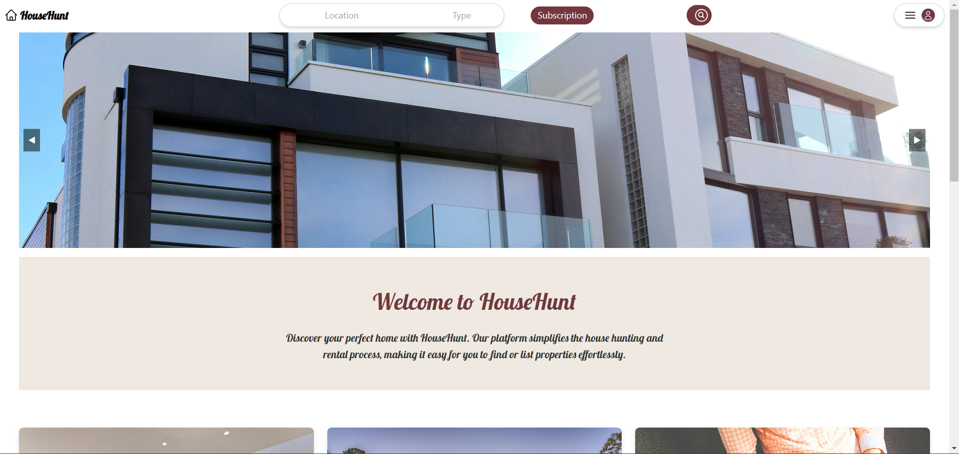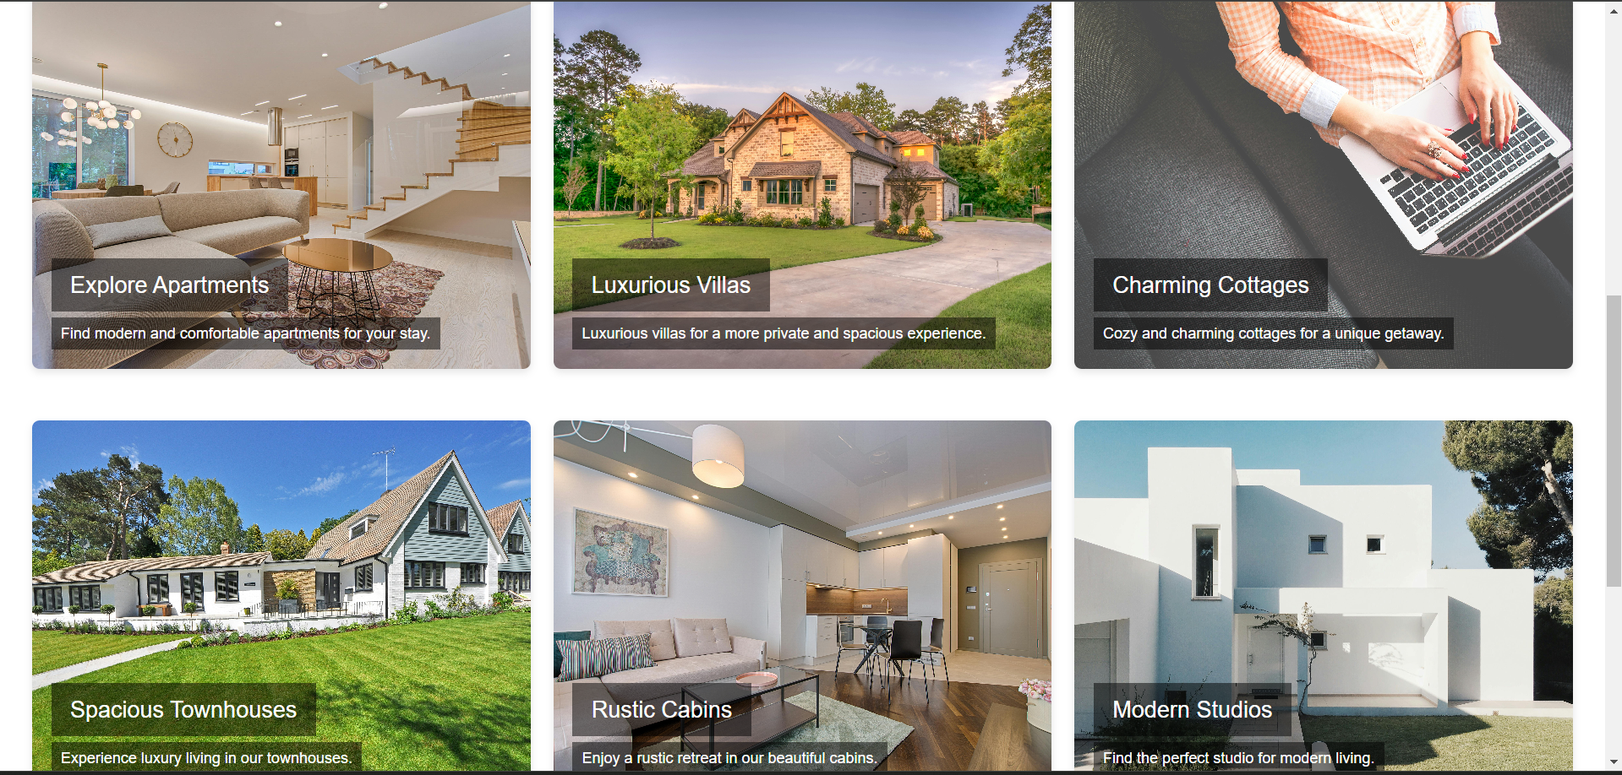 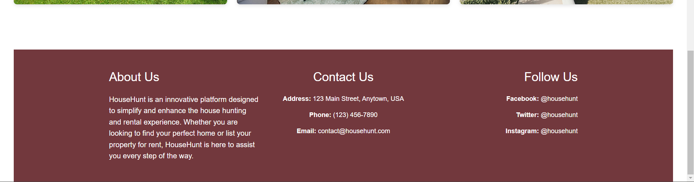

Login/Sign in Page

Upon clicking the login button located in the top right corner, the user is redirected to the login page. On this page, the user is presented with two options:

1. Login with Email:For users who already have an existing account.

2. Create New Account: For new users who wish to register for the application.

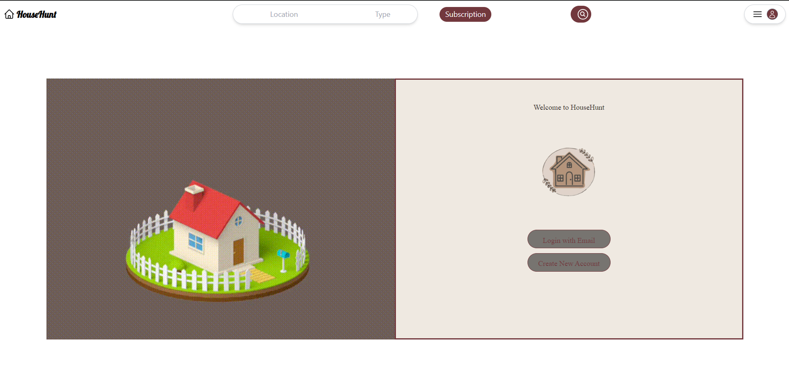

If the user selects "Login with Email," they are directed to a page where they must enter their correct email address and password to access their account.

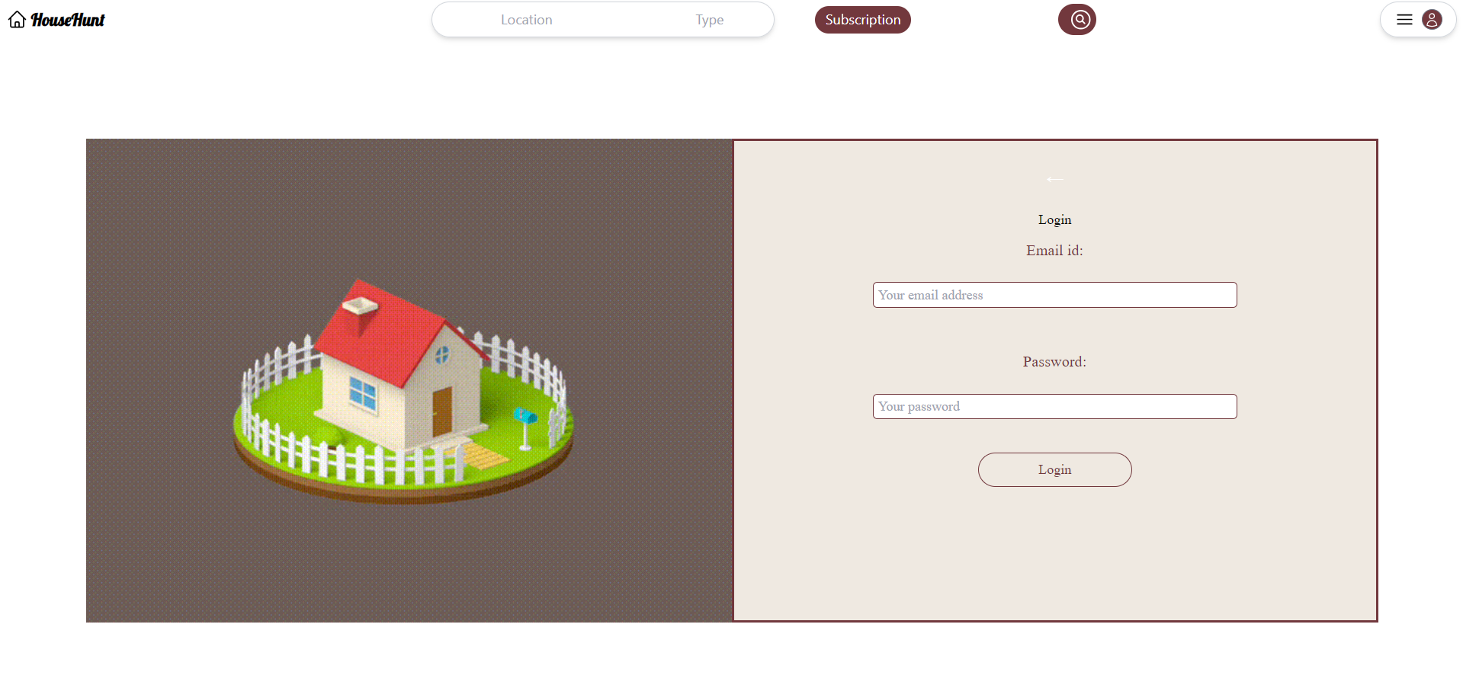

If the user selects the "Create New Account" option, they are directed to a page where they must provide their name, contact number, email address, and password to create a new account.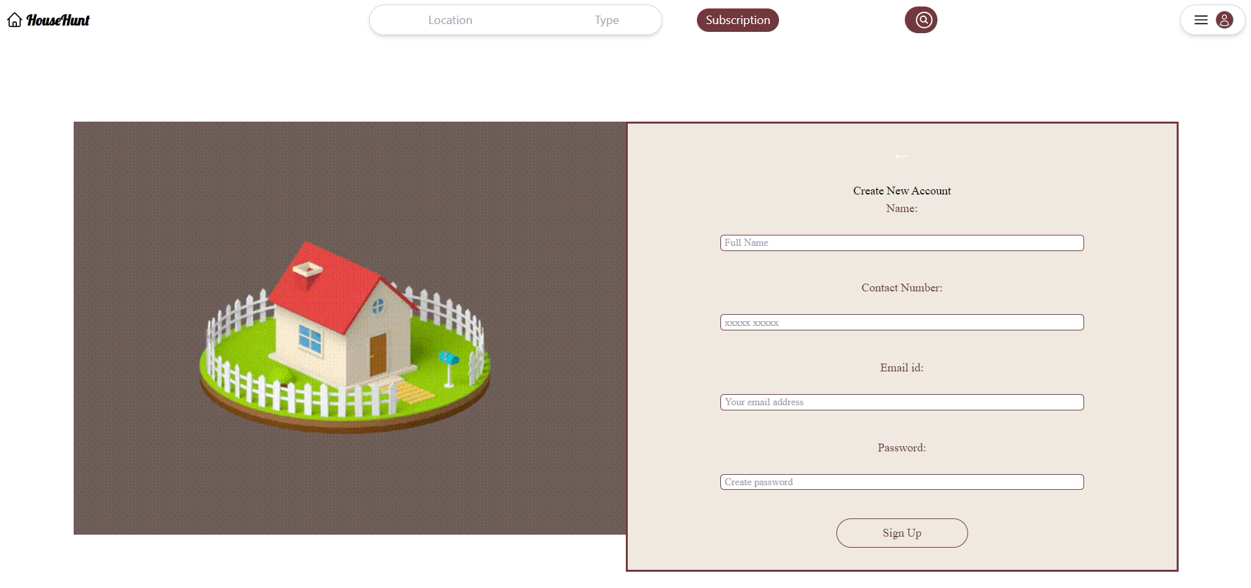

Subscription Page:

There are three different subscription plans offered: Basic (Budget-Friendly), Plus (Convenience Plus), and Premium (Full-Service). The plans are priced at $200/month, $300/month, and $500/month respectively.

Here is a breakdown of the features offered by each plan:

* **Basic (Budget-Friendly)**
  + Access to tenant portal
  + Submit maintenance requests online
  + Pay rent online
* **Plus (Convenience Plus)**
  + Includes all features of Basic plan
  + Renters insurance included
  + Credit reporting
  + Schedule move-in/out inspections online
* **Premium (Full-Service)**
  + Includes all features of Plus plan
  + Priority customer support
  + 24/7 emergency maintenance
  + Local mover & storage connections

Each plan has a "Choose Plan" button below it.

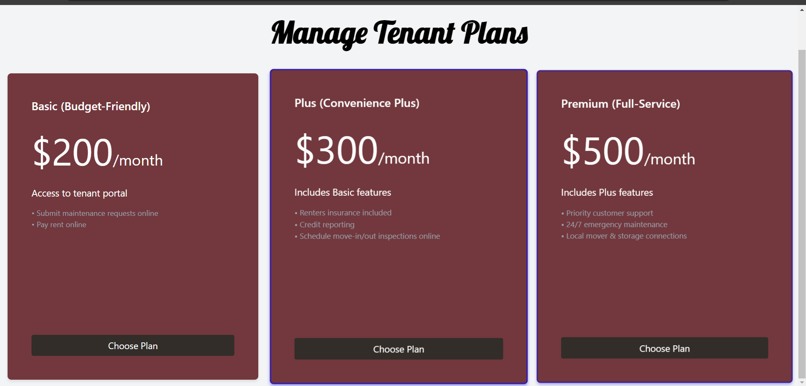

Post Your Property

This webpage allows users to submit a new property listing. Here are the details of the form:

* **Contact Information:**
  + Name
  + Email
  + Mobile Number
  + Aadhaar Number (likely a unique identification number in India)
* **Property Details:**
  + Title: Enter a title for your property listing.
  + Description: Describe your property in detail.
  + Price: Enter the asking price for your property.
  + Location: Enter the location of your property.
* **Images:** Upload multiple images to showcase your property.
* **Submit:** Once you have filled out all of the fields and uploaded your images, click the "Submit" button to submit your property listing.

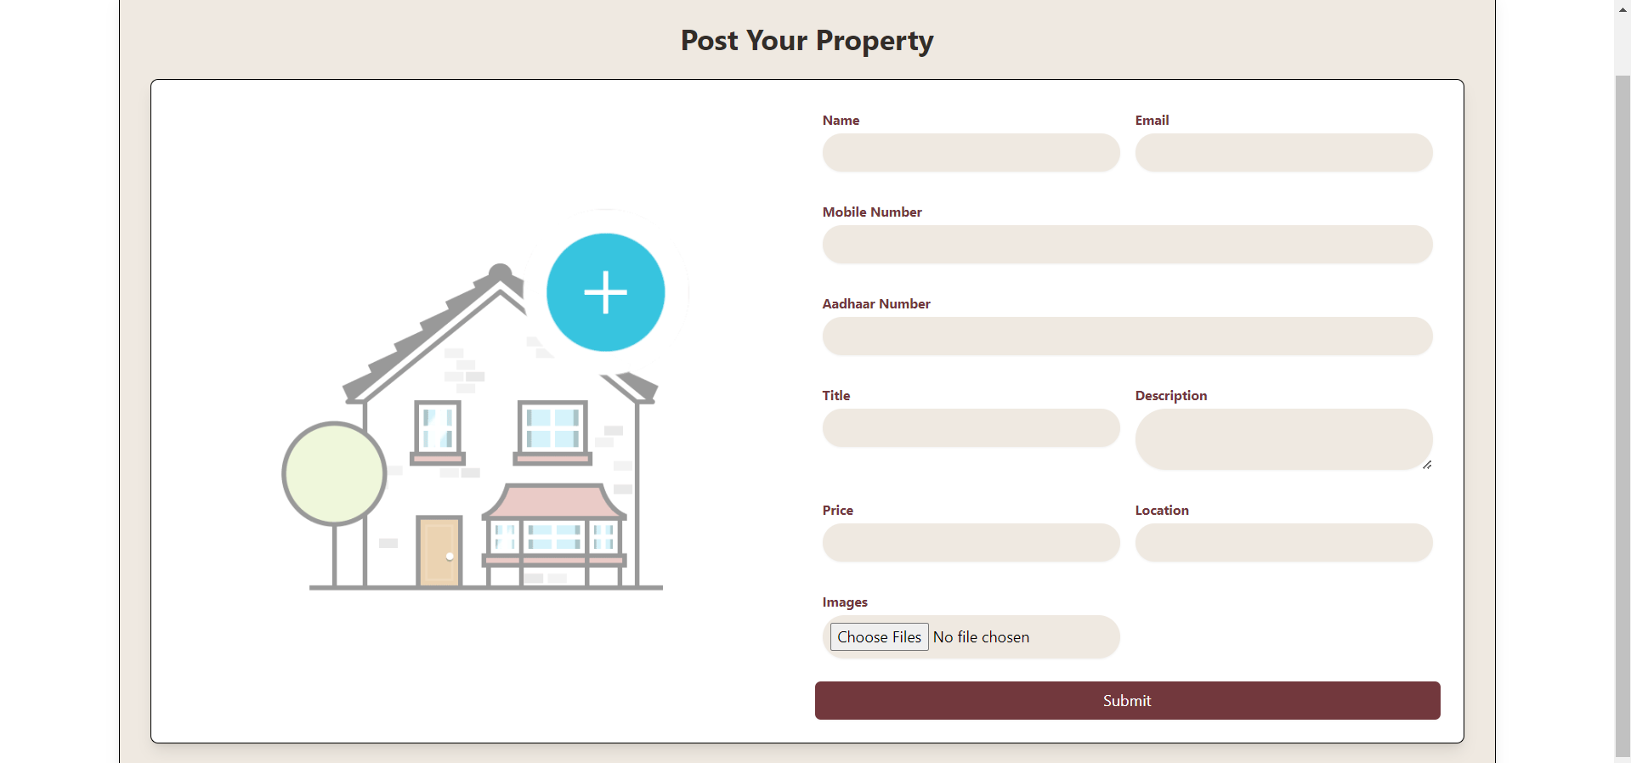

**Key Components**

1. **App.js**
   * Responsible for routing and main application layout.
2. **/components**
   * Contains reusable UI components used across the application.The different files used are

* # Carousel.css
* #HomePage.css

* + Along with that App.css is also used

1. **/pages**
   * Includes different pages for Web App. The different files in the pages folder are
   * arrow.jpg
   * arrow.png
   * # Carousel.jsx
   * Header.jsx
   * home.gif
   * home.mp4
   * homel.jpeg
   * # Homepage.jsx
   * house2.gif
   * imagel .jpg
   * image2.jpg
   * # LoadingAnimation.css
   * # LoadingAnimation.jsx
   * # LoginPage.jsx
   * logo-removebg-preview.p...
   * # PropertyForm.jsx
   * # PropertyFormPage.jsx
   * # SubscriptionPage.jsx

**Routing**

Routing is managed using React Router. Here are the main routes:

* **/Homepage** – The main homepage of the website
* **/subscription –** The subscription model page
* **/PropertyForm-** Post your property form
* **/login** – Login / Sign In page

**Integration with Backend**

The frontend communicates with the backend APIs hosted on [backend URL]. Key endpoints include:

* **USE /api/users** – Sign In page -Input for new user data
* **USE /api/auth** – Login page – checks for correct details
* **USE /api/properties** – Post your property page – allows user to enter the details of the property

**User Interface (UI) Design**

* The UI design follows a user-centric approach, emphasizing ease of navigation, accessibility, and a clean, modern aesthetic.

Implemented using Bootstrap for responsive design, with additional customization using CSS and JavaScript for interactive elements.